Programming 1(P1): Building xv6, Part 1.

(I, **Zachary Doctrove**, completed this project by myself)

Screenshot #1: After having created the container following the lab instructions, I am now able to **restart** and **attach** my xv6cp container. I included the date command and my Docker username as well (This doesn’t show xv6 directly running, so I included an additional screenshot)

(Full shot)

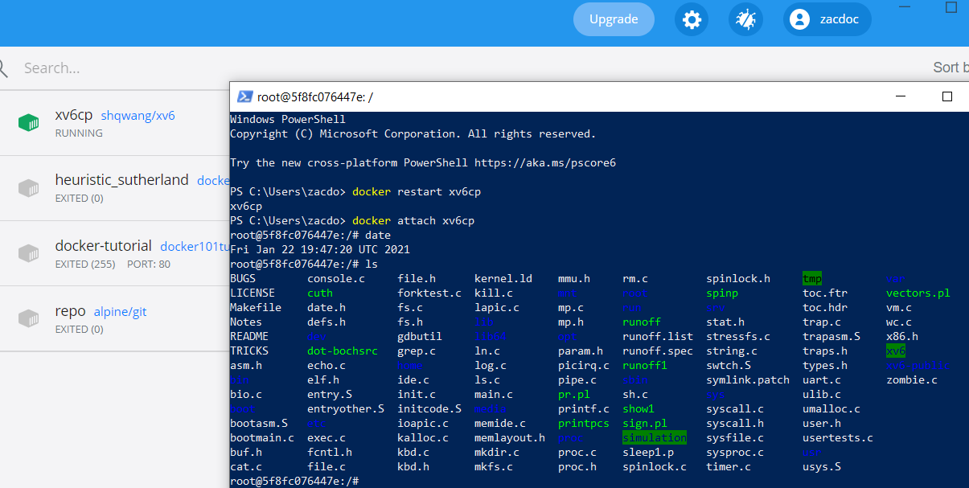



(Close up of restart & attach)

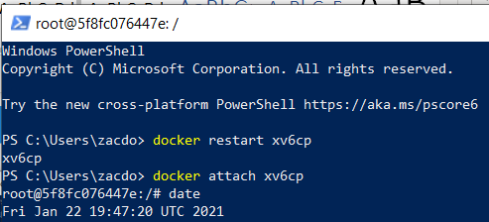



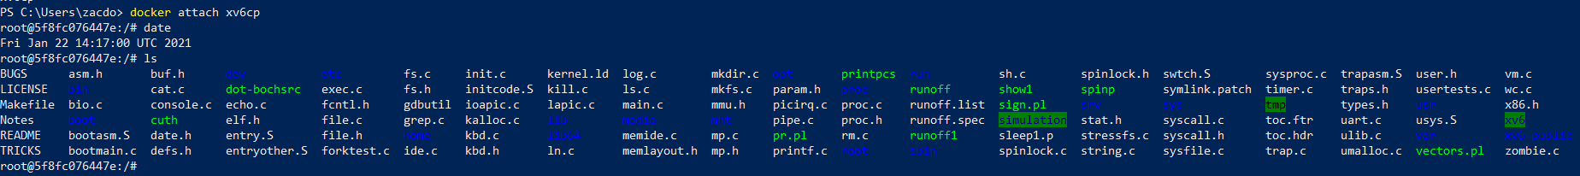(Listing off all the items at the xv6cp’s root)

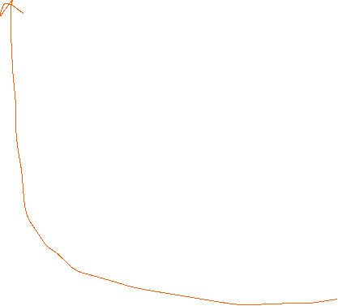

The “xv6” directory is directly connected to the xv6 file on my windows 10 operating system (C:\Users\zacdo\xv6)



Screenshot #2: After the container was created, I then built and ran xv6. I then listed off the contents of xv6.

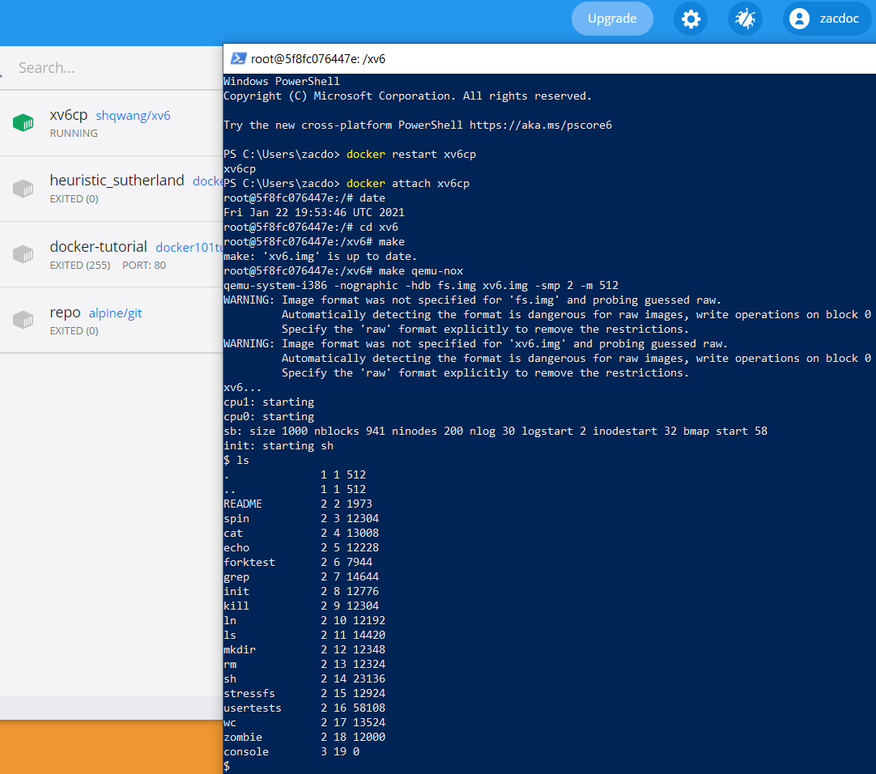



Screenshot #3: A few hours later, I started up the xv6 operating system in order to see what’s inside of “README”

